**MUSIC STORE DATA ANALYSIS**

1. **What is the senior most employee based on job title**

SELECT TOP 1 * FROM employee ORDER BY levels DESC

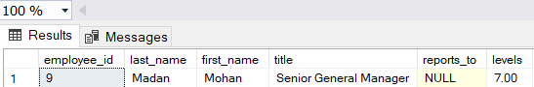

1. **Which countries have the most invoices**

SELECT COUNT(*) AS Number_of_invoices, billing_country FROM invoice GROUP BY billing_country ORDER BY Number_of_invoices DESC

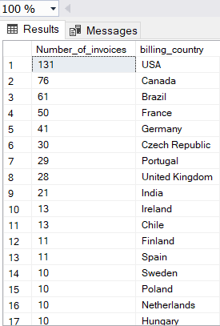

1. **What are top 3 values of total invoice**

SELECT TOP 3 total FROM invoice ORDER BY total DESC

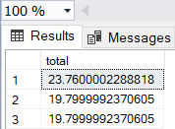

1. **Which City has the best customer? We would like to throw promotional Music Festival in the city we made the most money. Write a query that returns one city that has the highest sum of invoice totals return both the city name & sum of all invoice total**

SELECT TOP 1 billing_city, SUM(total) AS Total_invoice FROM invoice GROUP BY billing_city ORDER BY Total_invoice DESC

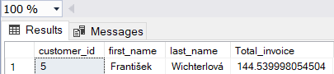

1. **Who is the best Customer? The Customer who has spend the most money will be declared the best customer, Write a query that return the person who has spent the most money**

SELECT TOP 1 customer.customer_id, customer.first_name, customer.last_name, SUM(invoice.total) AS Total_invoice FROM customer

JOIN invoice ON customer.customer_id = invoice.customer_id

GROUP BY customer.customer_id, customer.first_name, customer.last_name

ORDER BY Total_invoice DESC

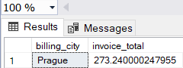

1. **Write query to return the email, first name, last name & Genre of all Rock music listeners, Return your list ordered alphabetically by email sorting with A**

SELECT DISTINCT email, first_name, last_name FROM customer

JOIN invoice on customer.customer_id = invoice.customer_id

JOIN invoice_line ON invoice.invoice_id = invoice_line.invoice_id

WHERE track_id IN( SELECT track_id FROM track

JOIN genre ON track.genre_id = genre.genre_id WHERE genre.name LIKE 'Rock')

ORDER BY email;

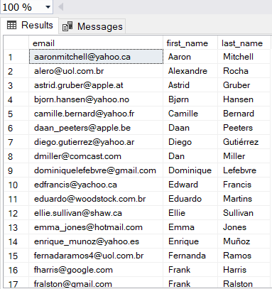

1. **Let’s invite the artist who have written the most rock music in our dataset, write a query that returns the artist name and total track count of the top 10 rock bands**

SELECT TOP 10 artist.artist_id, artist.name, COUNT(artist.artist_id) AS total_trackes

FROM track

JOIN album ON album.album_id = track.album_id

JOIN album2 ON album2.album_id = album.album_id

JOIN artist ON artist.artist_id = album2.artist_id

JOIN genre ON genre.genre_id = track.genre_id

WHERE genre.name LIKE 'Rock'

GROUP BY artist.artist_id, artist.name

ORDER BY total_trackes DESC

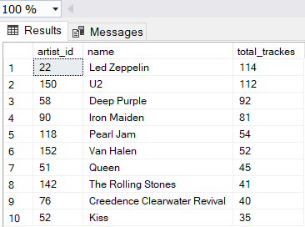

1. **Return all the tracks names that have a song length longer than the average song length. Return the name and milliseconds for each track. Orders by the song length with the longest songs listed first.**

SELECT name, milliseconds FROM track

WHERE milliseconds > (SELECT AVG(milliseconds)FROM track) ORDER BY milliseconds DESC

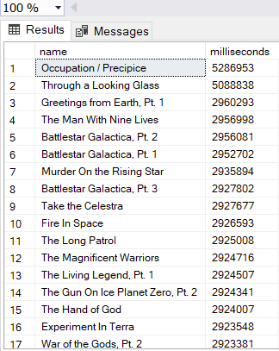

1. **Find how much amount spent by each customer on artist? Write a query to return customer name, artist name and total spent**

SELECT customer.first_name, customer.last_name, artist.name, SUM(invoice.total) AS total_spent FROM invoice

JOIN customer ON customer.customer_id = invoice.customer_id

JOIN invoice_line ON invoice_line.invoice_id = invoice.invoice_id

JOIN track ON track.track_id = invoice_line.track_id

JOIN album ON album.album_id = track.album_id

JOIN album2 ON album2.album_id = album.album_id

JOIN artist ON artist.artist_id = album.artist_id

GROUP BY customer.first_name, customer.last_name, artist.name ORDER BY total_spent DESC

